September 4, 2020

Dear Awana Families,
I have great news! Awana will be starting September 20th! We welcome your family back for another fun-filled year! Our focus this year is to provide a safe place for your kids to connect while we shift from our “normal” look of club to a unique and creative way to provide the same Bible-based experience and a sense of belonging.
We will be doing a hybrid version of face to face and virtual club this fall. The schedule of the first 4 weeks is below.
 | Cubbies  (3 and 4yr old) | Sparks  (K – 2nd grade) | T & T  (3rd – 6th grade) | Trek  (7th & 8th grades)
Sept. 20 | 2:00 – 3:30  In-person at Fulton Church | 2:00 – 3:30  In-person at Fulton Church | 2:00 – 3:30  Registration and outdoor activity at church | 2:00 – 3:30  Registration and outdoor activity at church
Sept. 27 | 2:30 Virtual  (about 30 minutes) | 2:30 Virtual (about 30 minutes) | 2:00 – 3:30  In-person at Fulton Church | 2:00 – 3:30  In-person at Fulton Church
October 4 | 2:00 – 3:30  In-person at Fulton Church | 2:00 – 3:30  In-person at Fulton Church | 2:00 – 3:30  Outdoor activity at church (weather depending) | 2:00 – 3:30  Outdoor activity at church (weather depending)
October 11 | 2:30 Virtual (about 30 minutes) | 2:30 Virtual (about 30 minutes) | 2:00 – 3:30  In-person at Fulton Church | 2:00 – 3:30  In-person at Fulton Church

We hope to do as many outdoor activities as possible until the weather changes. Some activities for older kids may take place off site. If that is the case, we will communicate any changes of time and location.

Safety and hygiene
We will obey all Wisconsin Governor and/or Wisconsin Department of Health Services directives. Face masks must be worn while in the buildings on Fulton Church campus. Hand sanitizer will be available and it’s use encouraged when entering/leaving a building or main group rooms. Social distancing will be practiced.

Checking for Symptoms Before Club
We are relying on parents/guardians to screen their child(ren) at home before coming to club to ensure no COVID-19 symptoms are present.
- Clubbers and leaders are required to stay home if they have any NEW or WORSENING symptoms or combinations of symptoms: Cough, shortness of breath, fever of at least 100 degrees, chills, sore throat, runny nose, muscle pain, headache, and new loss of taste or smell.
- Note: not everyone with COVID-19 has all of these symptoms. For many, symptoms are mild, with no fever. Some people may also experience fatigue or gastrointestinal symptoms such as nausea, vomiting, diarrhea, or abdominal pain. It is important to know that you can still spread (transmit) the virus to others even if you have mild or no symptoms
- Please review CDC guidelines on their website

Things to remember when coming to club:
- Registration will be available on the first day of club. After the first day, please contact Annette Mathews to receive registration forms.
- On the first day of club, drop off clubbers in person at designated locations. Curbside pick-up and drop-off will be in the circular drive and historic sanctuary after first day of club.

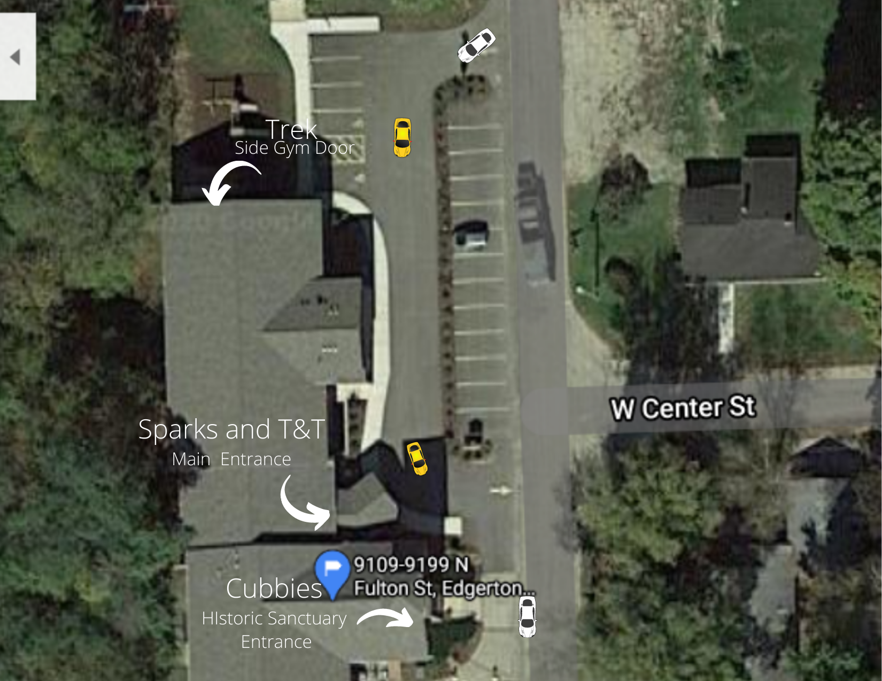

- Bring your own mask. Masks must cover mouth and nose. Bandanas and neck gaiters are not allowed. Shields may be worn in conjunction with a face mask.
- Drinking fountains may not be operational. Please bring a water bottle with name clearly marked on it

We will continue to re-evaluate our schedule and status since circumstances during this time of COVID-19 are very fluid.

With these measures in place, it is our hope that you will join us for club this fall! Please fill out this google form https://forms.gle/LKU7vgE1xkcYuFuh9 to let us know you’re interested in Awana this year. If you have any questions, please contact me.

Annette Mathews
Awana Ministry Director
Fulton Awana Clubs
608-884-8512
amathewsandfamily@gmail.com

